Title or Task: | Title  

Description:

Files Required
Suitable for Classes: | All classes
Area: | Technology & Enterprise
Teacher: | Mr Peter Faulks

Timeline

Date Due:

Task Brief:

Outcomes:

Items highlighted in yellow are tasks for you to complete
Items in Blue italics are help tips

Photoshop

Create Animations my fox in Photoshop

Copy each image (see end od this document) of a fox to Photoshop as 01, 02 or Fox 01, Fox 02 etc in individual layers

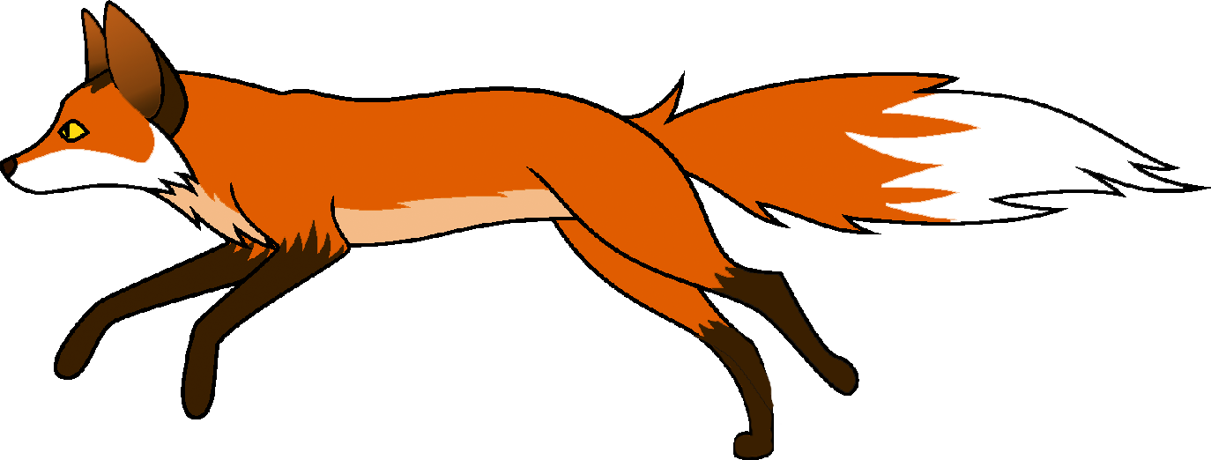
1 Create a document with each frame of the animation on a different layer
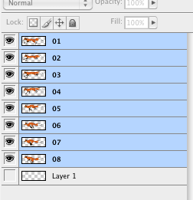

2 Select the layers to be used in the animation from the layers palette.

- Note: To select a group of layers, select the layer at the top of the group. Then hold the shift key and click on the bottom layer. This will highlight every layer in between.

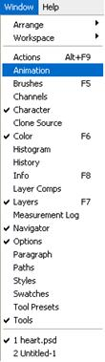
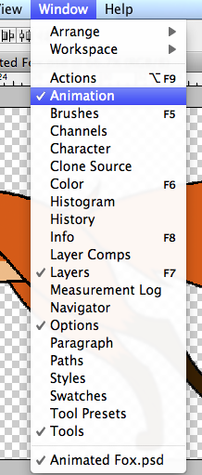
  Open the animation palette by choosing "Window" from the menu bar and selecting “Animation.“ When the animation palette opens, it should look like the photo below. If it doesn’t, that means it opened in the timeline view.
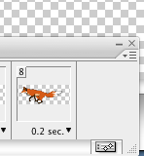
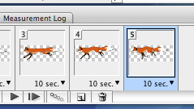

 Change the frame animation view. Click on the "Flyout" menu in the upper right hand corner of the animation palette and select “Convert to Frame Animation.”
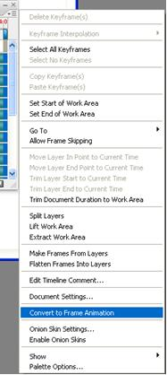

 Change every layer showing on one frame to every layer showing on its own frame. Click the "Flyout" menu on the animation palette and choose “Make frames from layers.”

- Note: All layers don’t have to be selected. To select a few layers, use the copy layer button at the bottom right of the animation palette to add layers.
 Modify each frame. Select the frame on the animation window and change it as desired in the main Photoshop window.
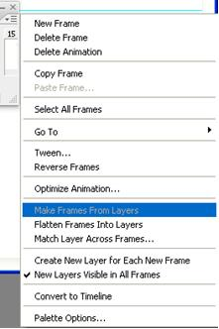
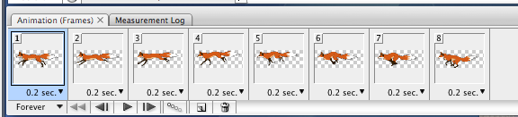
- Note: To add or remove a graphic from another layer to any frame, select the frame and in the layers palette, click the “eye” to toggle on or off the visibility for that layer. Then drag the image to a NEW frame
 Click on the arrow head under each frame to display the timing menu. Select the display time for each frame. Try .2 secs each
Test the animation with the play button
 From the file menu, select export to export the document as a movie. Alternatively, you could go to the "Save" option and save the file as a GIF. Be sure to select "Save for Web and Devices" (.gif under this option).
- Note: If you want to loop your animation continuously, you can select that option in the window that pops up after you have chosen "Save For Web and Devices". Under the color table that shows up is "Looping options."Select "forever" and save it. You can also pick "others" and select the amount of times you want your animation to loop.

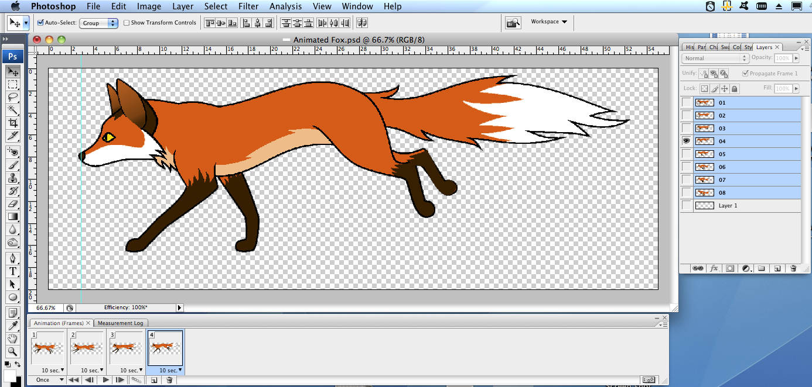

The foxes
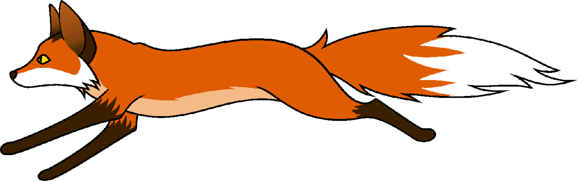
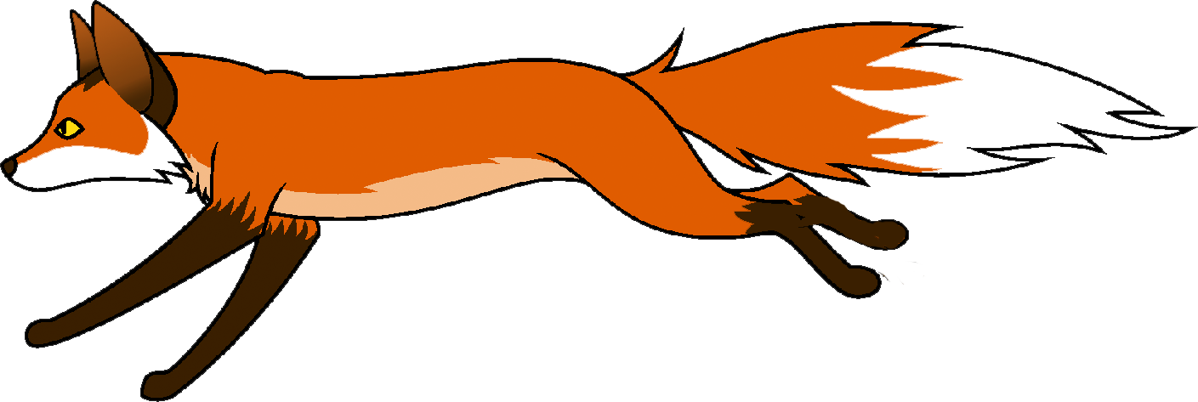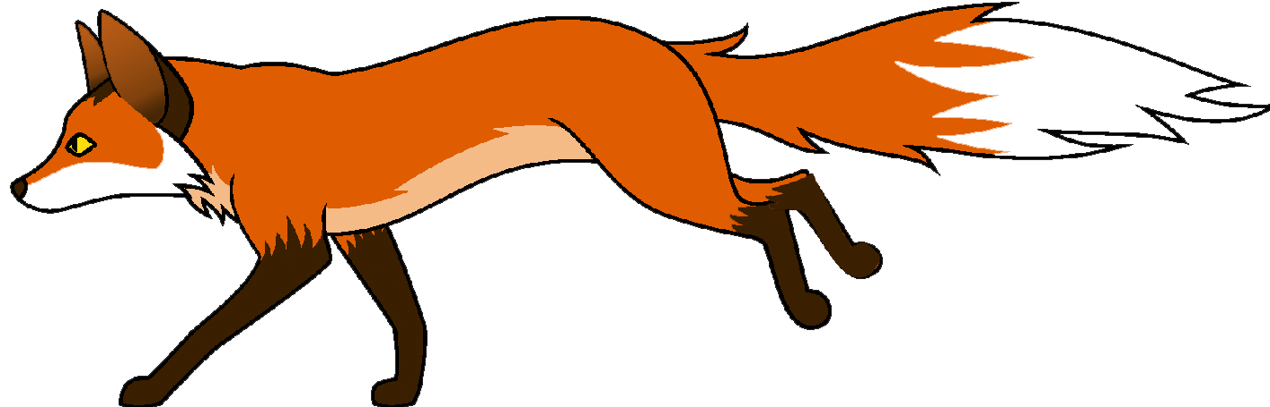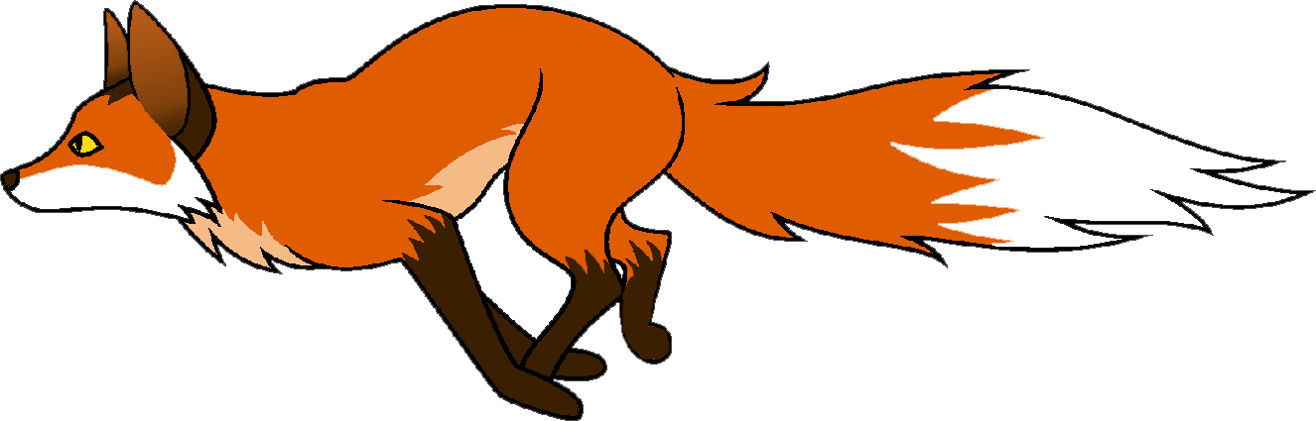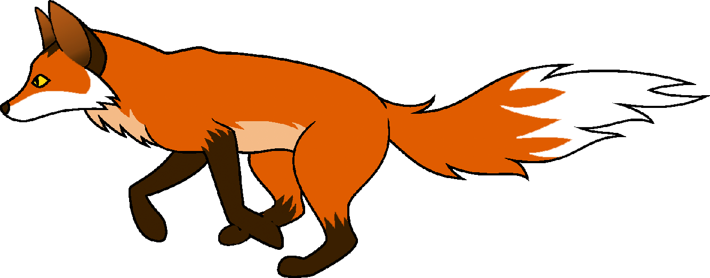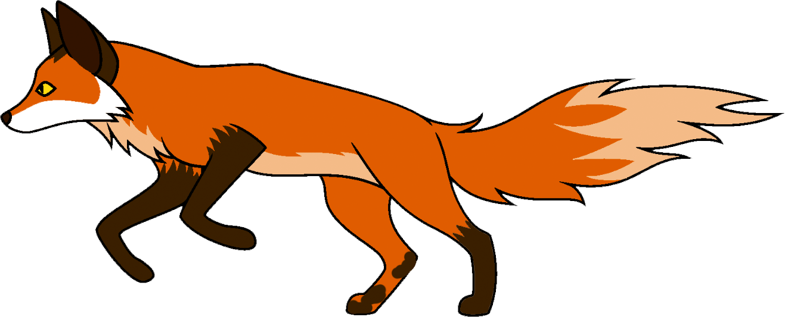


Need help just ask

